

DIVINE SECONDARY SCHOOL KITALA

BEGINNING OF TERM TWO EXAMS 2024

**S.2 BIOLOGY**

TIME: 2 HOURS

NAME…………………………………………………………………………………………………………………..SIGN………………….

LIN……………………………………………………………………………………………………………………………………….

INTSTUCTIONS

ANSWER ALL ITEMS

1. Your parents have obtained three pieces of land in different locationsespecially in Wakiso, Mityanaand Mukono.Three soil samples have beenobtained fromthe landsA,B andC.

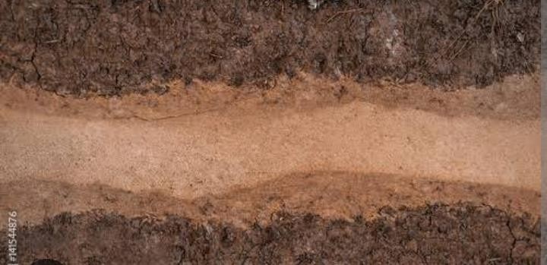

1. You are required to design an experiment to analyse the soil samples and suggest one farm where fish pond can be constructed. (10scores)
2. Give other ways through which the farm can be put into use. (05scores)
3. Organisms are grouped according to similarities and differences in their characteristics. Use characteristics of skins, eggs and methods of temperature regulation only. Classify Rat, Tilapia, Lizard, Hen and Toad into classes of phylum Chordata. (15scores)

**SUPPORT MATERIAL**

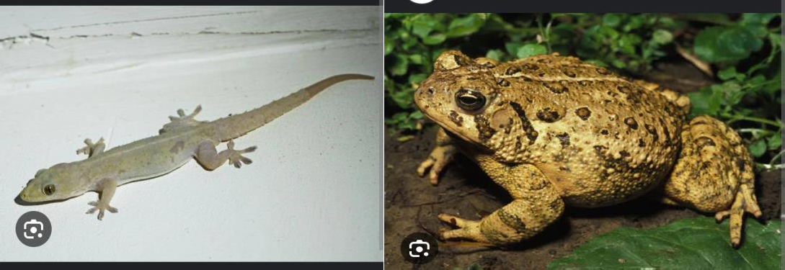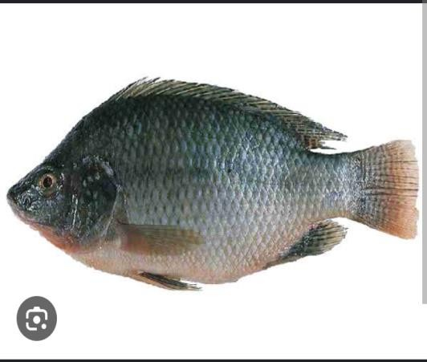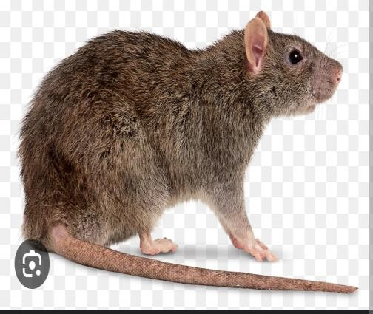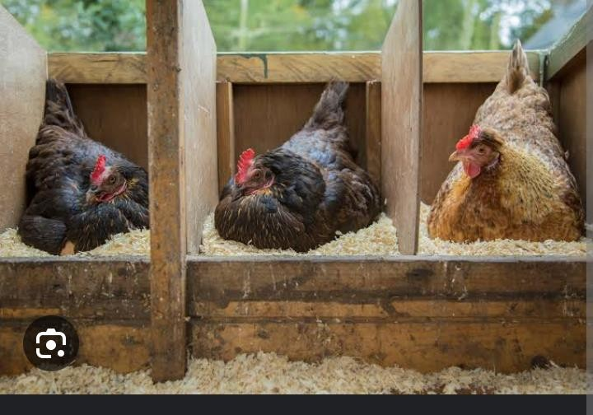

1. Soilisthecoveringoftheearth’ssurfaceinwhichplantsgrowandsomemicroorganisms andanimalslive.



1. Stateanysix componentsofsoil. (06 scores)
2. Asampleofsoilwas obtainedfromtheschoolgarden.Itwas foundtocontain someMicroorganismsand water.

Statetheroleplayed by

1. Microorganismsinthesoil. (02scores)
2. Waterinthesoil. (02scores)
3. A group of senior Three Learners obtained the following results whileanalyzinga soilsample.

Volumeofsoil = 200cm3

Volumeofwater 300cm3Volumeofwaterandsandafterstirring =450cm3

1. Determinethecomponentofsoilbeinginvestigated. (01score)
2. Calculatethepercentagecompositionoftheabovecomponentinthesoil.(04scores)

END

NO SWEAT, NO SUCCESS.